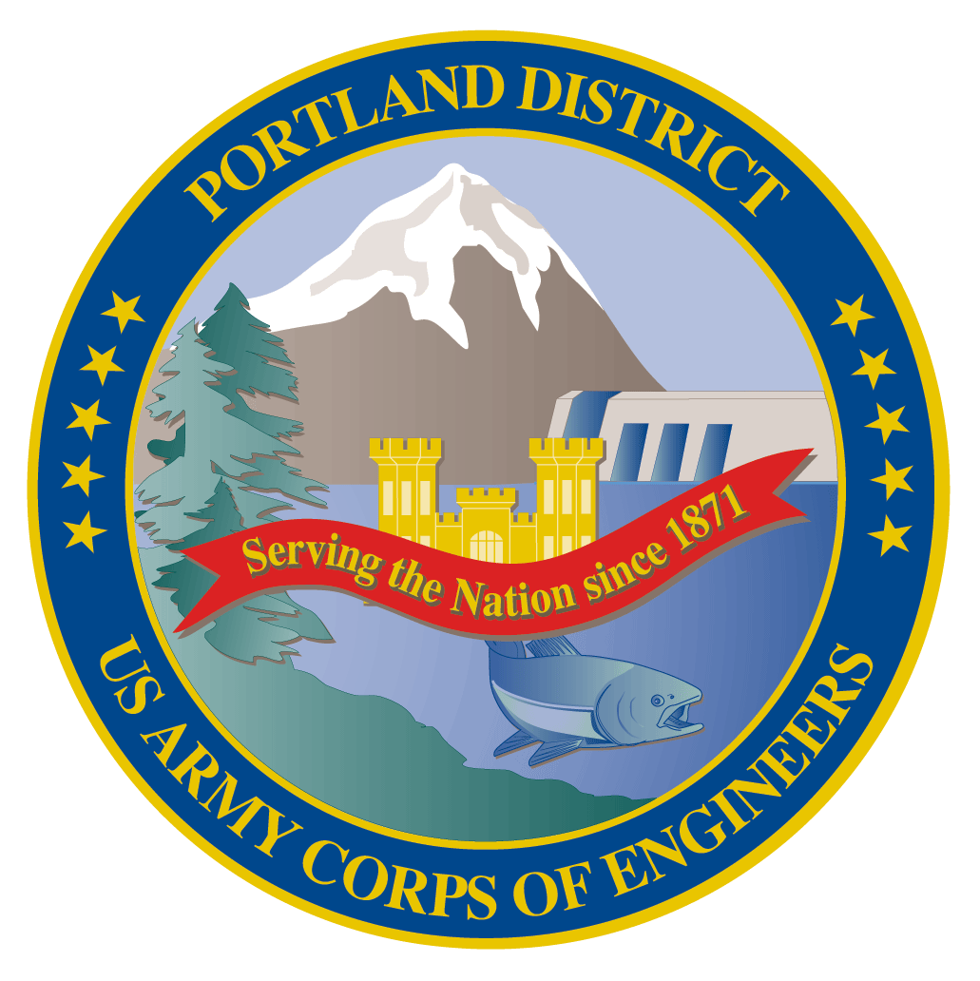
Lower Columbia River Fish Facility Design Review Work Group (FFDRWG)

USACE, Portland District

August 2022 Meeting Agenda
August 4, 2022 09:00-11:00
Join Meeting: https://usace1.webex.com/join/jacob.macdonald
Join by phone (audio only, no Webex): (844) 800-2712 | Access Code: 1995 00 9820

FFDRWG meeting Files
http://pweb.crohms.org/tmt/documents/FPOM/2010/FFDRWG/2022%20FFDRWG/

Introductions
FFDRWG members:
BPA
Scott Bettin
Kim Johnson
Siena Lopez-Johnston
Christine Petersen
Greg Smith
Leah Sullivan
Ben Hausmann
NOAA
Blane Bellerud
Gabriel Brooks
Trevor Conder
Kinsey Frick
Claire McGrath
Josie Thompson
Logan Negherbon
Kelsey Swieca
USFWS
Dave Swank
Shelby Fowler
States
Erick Van Dyke (ODFW)
Charles Morrill (WDFW)
Jonathan Ebel (IDFG)
CRITFC/Tribes
Tom Lorz (CRITFC)
Blaine Parker (CRITFC)
Tom Skiles (CRITFC)
Laurie Porter (CRITFC)
Greg Silver (CRITFC)
Casey Baldwin (CTCR)
Michael Karnosh (CTGR)
Lawrence Schwabe (CTGR)
Torey Wakeland (CTGR)
Aaron Jackson (CTUIR)
Ralph Lampman (YN)
NPCC
Leslie Bach
Kris Homel
FPC
Erin Cooper
PSMFC
Alan Brower
Darren Chase
Roger Clark
Mark Leonard
Scott Livingston
Nicole Tancreto
Don Warf
CENWD
Doug Baus
Tim Dykstra
Dan Feil
Mike Langeslay
Cindy Studebaker
Lisa Wright
CENWW
Chris Peery
Steve Juhnke
CENWP-OD
Andrew Derugin
Rebecca Cates
Jeanette Wendler
Tucker Gossett
Bob Cordie
Jeffrey Randall
Eric Grosvenor
Michael Lotspeich
Laura Rickets
Tammy Mackey
Robert Wertheimer
Patricia Madson
Darren Gallion
CENWP-PM
Jim Adams
Ian Chane
Jeff Hicks
Steve Sipe
Jeremiah Woodard
Erin Kovalchuk
Mark Bierman
Brad Eppard
Nathan McClain
Jake Macdonald
Jon Rerecich
Ida Royer
David Trachtenbarg
Scott Fielding
CENWP-ENC
Adam White
Brandt Bannister
Bridget Bell
Shari Dunlop
Curtis Lipski
Chris Motti
Steve Schlenker
Max Wilson-Fey
Collin Porter
Dan Penn

Action items from previous meetings
- Corps will present The Dalles backup AWS debris management alternatives at an upcoming FFDRWG
  - EDR shelved at 50% with no funding in FY 22 until recently. Project is reactivated and the Corps (Rerecich) will walk through 60% alternatives with FFDRWG at the September 1st meeting.
- TDA lamprey PDT will discuss FFDRWG’s recommended option for exit weirs 154-157 (option #3, spacer attached to the bottom of the weirs) and Adam White will report any significant developments at the next FFDRWG meeting.
- Jake Macdonald will add John Day ladder cooling as a standing topic on the FFDRWG agenda
- Scott Fielding will lead a FFDRWG discussion of the available data for JDA ladder cooling. This discussion will help determine the path forward on design and construction of a ladder cooling structure prior to the FY25 budget request submission in December 2022.

Topics for FFDRWG Discussion/Review/Coordination
- BON2 FGE – Jim Adams (PM), Max Wilson-Fey (TL), Jon Rerecich (FC)
  - Update on hydraulic testing – Wilson-Fey
- BON2 control section redesign – Jeremiah Woodard (PM), Shari Dunlop (TL), Andrew Derugin (FC)
  - 60% DDR is available for FFDRWG review at: https://pweb.crohms.org/tmt/documents/FPOM/2010/FFDRWG/2022%20FFDRWG/DDR_BON2%20WA%20Shore%20Control%20Section%20Modifications_60_ATR.pdf
  - Overview of 60% DDR - Dunlop
- (it’s back!!) TDA Backup AWS debris management – Erin Kovalchuk (PM), Mehdi Roshani (TL), Jon Rerecich (FC)
  - Presentation of 60% alternatives at the September 1st FFDRWG - Rerecich
- JDA adult lamprey passage improvements – Jeremiah Woodard (PM), Adam White (TL), Jake Macdonald (FC)
  - 60% DDR available for FFDRWG review at: https://pweb.crohms.org/tmt/documents/FPOM/2010/FFDRWG/2022%20FFDRWG/JDA%20Lamprey%20Passage%20DDR_ATR.pdf
  - In-house construction, no 90% DDR and no BCOES, straight from 60% to 100%. Construction in Winter 2022-2023.
- TDA adult lamprey passage improvements – Jeremiah Woodard (PM), Adam White (TL), Jake Macdonald (FC)
  - 60% DDR available for FFDRWG review at: https://pweb.crohms.org/tmt/documents/FPOM/2010/FFDRWG/2022%20FFDRWG/TDA%20Lamprey%20Passage%20DDR_60.pdf
- BON1 adult lamprey passage improvements – Jeremiah Woodard (PM), Adam White (TL), Andrew Derugin (FC)
  - 60% DDR available for FFDRWG review at: https://pweb.crohms.org/tmt/documents/FPOM/2010/FFDRWG/2022%20FFDRWG/TDA%20Lamprey%20Passage%20DDR_60.pdf
- Other topics
  - John Day Ladder Cooling
    - Continue discussion of available data and development of a recommendation for the 2025 budget capability submission in December 2022 - Fielding

